**Simulate Paging Technique of memory management**

**Algorithm:**

Start.

1. Read the memory size.
2. Read the page size.
3. Calculate the total number of pages by using the relation,

Number of pages=Memory size/ Page size.

1. Read the number of processes.
2. I) Read the number of pages required for the process.

II) Check if the number of pages for the current process is more than the pages available.

If yes,

Display the message that the memory is full and go to step 6.

If no,

Update the number of pages available in memory by using the relation,

***Remaining pages=Remaining pages -The number of pages required for the current process****.*

III) Read the page table for the current process.

Repeat step 5 until all the processes get processed.

1. I) Read the Process number, page number and the offset.

II) Check:

If process number is greater than the total number of processes,

If page number is greater than the total pages of the current process,

If offset is greater than the page size.

If any of these conditions become yes then

Display the message**: “Invalid Process or Page number or Offset.”**

If none of the conditions become true then calculate the physical address using the relation,

***Physical Address= (fno[X][Y]*Page size)+Offset.***

Stop.

**Code:**

#include<stdio.h>

#include<conio.h>

main()

{

int ms, ps, nop, np, rempages, i, j, x, y, pa, offset; int s[10], fno[10][20];

clrscr();

printf("\nEnter the memory size -- ");

scanf("%d",&ms);

printf("\nEnter the page size -- ");

scanf("%d",&ps); nop = ms/ps;

printf("\nThe no. of pages available in memory are -- %d ",nop);

printf("\nEnter number of processes -- ");

scanf("%d",&np);

rempages = nop;

for(i=1;i<=np;i++)

{

printf("\nEnter no. of pages required for p[%d]-- ",i);

scanf("%d",&s[i]);

if(s[i] >rempages)

{

printf("\nMemory is Full");

break;

}

rempages = rempages - s[i];

printf("\nEnter pagetable for p[%d] --- ",i);

for(j=0;j<s[i];j++) scanf("%d",&fno[i][j]);

}

printf("\nEnter Logical Address to find Physical Address ");

printf("\nEnter process no. and pagenumber and offset -- ");

scanf("%d %d %d",&x,&y, &offset);

if(x>np || y>=s[i] || offset>=ps)

printf("\nInvalid Process or Page Number or offset");

else

{

pa=fno[x][y]*ps+offset;

printf("\nThe Physical Address is -- %d",pa);

}

getch();

}

**Input/Output:**

**Case 1: VALID**

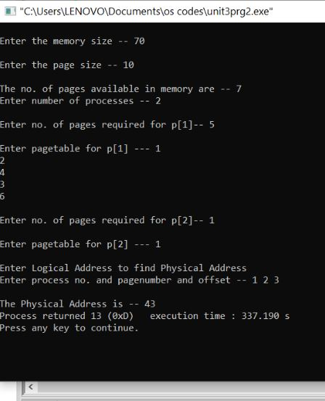

**Case 2: INVALID**

